**MAHENDRA INSTITUTE OF TECHNOLOGY**

|  |  |  |  |  |  |  |  |  |  |  |  |  |  |
| --- | --- | --- | --- | --- | --- | --- | --- | --- | --- | --- | --- | --- | --- |
|  | **Department of Computer Science and Engineering**  **Smart Farmer-IOT Enabled Smart Farming Application**  **IBM NALAIYATHIRAN**  **Project Design Phase-I**  **Solution Architecture**   |  |  | | --- | --- | | **TITLE** | **Smart Farmer-IOT Enabled Smart Farming Application** | | **DOMAIN NAME** | INTERNET OF THINGS | | **TEAM ID** | PNT2022TMID17252 | | **LEADER NAME** | KARTHICKRAJA M | | **TEAM MEMBER NAME** | KAVIN M  KAVIYARASAN R  LOGANATHAN K | | **MENTOR NAME** | DIVYA BHARATHI G | |

**Solution Architecture:**

* The different soil parameters (temperature, humidity, light intensity, pH level) are sensed using different sensors and the obtained value is stored in IBM cloud.
* Arduino UNO is used as a processing unit which processes the data obtained from sensors and weather data from weather API.
* Node red is used as a programming tool to wire the hardware, software and APIs. The MQTT protocol is followed for communication.
* All the collected data are provided to the user through a mobile application which was developed using MIT app inventor. The user could make decision through an app, whether to water the crop or not depending upon the sensor values.

**Solution Architecture Diagram:**

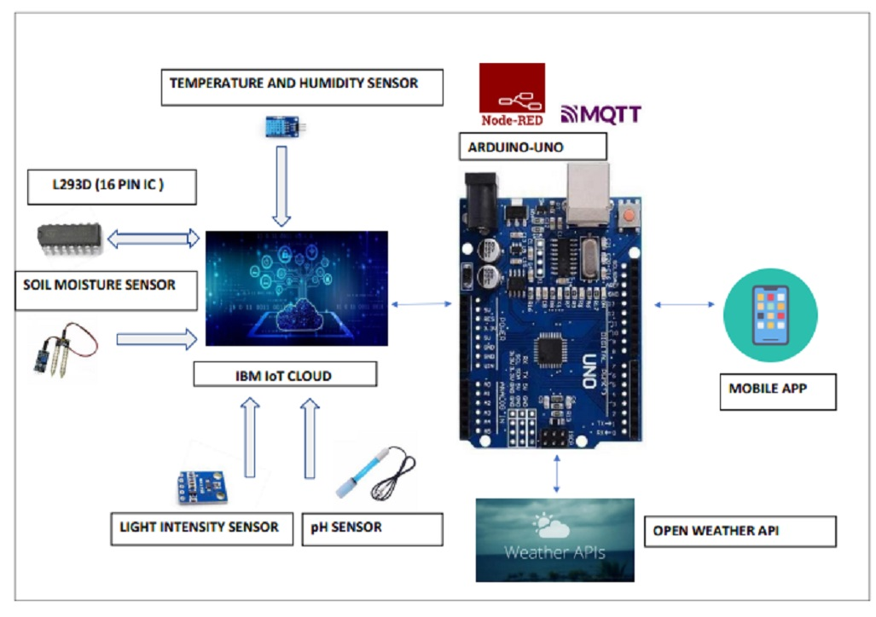

­­

**Reference:** [**https://aws.amazon.com/blogs/industries/voice-applications-in-clinical-research-powered-by-ai-on-aws-part-1-architecture-and-design-considerations/**](https://aws.amazon.com/blogs/industries/voice-applications-in-clinical-research-powered-by-ai-on-aws-part-1-architecture-and-design-considerations/)